Python Assignment -1
Question 1. Write a prime generator program using only primes and using python loops.
Explanation:
is_prime Function:
This function takes a number num as input and returns True if num is a prime number, and False otherwise.
It first checks if num is less than 2, in which case it returns False because prime numbers must be greater than 1.
Then, it iterates through the range from 2 to the square root of num (inclusive) using a for loop.
Within the loop, if num is divisible by any number in this range, it returns False, indicating that num is not a prime number.
If the loop completes without finding any divisors, the function returns True, indicating that num is a prime number.
prime_generator Function:
This function defines a generator that yields prime numbers indefinitely.
It initializes an empty list primes to store prime numbers.
Then, it enters an infinite loop where it iterates through increasing numbers starting from 2.
Within each iteration, it checks if the current number (num) is divisible by any of the previously generated prime numbers (primes). If num is not divisible by any of them, it appends num to the primes list and yields num.
After yielding a prime number, it increments num by 1 and continues the loop indefinitely.

Code:
def is_prime(num):
if num < 2:
return False
for i in range(2, int(num**0.5) + 1):
if num % i == 0:
return False
return True
def prime_generator():
primes = []
num = 2
while True:
if all(num % prime != 0 for prime in primes):
primes.append(num)
yield num
num += 1
generator = prime_generator()
for _ in range(20): # Generating first 20 prime numbers
print(next(generator))

Program Output:
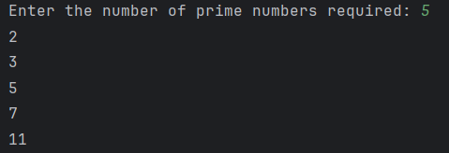

Question 2. Write a discount coupon code using dictionary in Python with different rate coupons for each day of the week.
Explanation:
This code defines a dictionary named day_coupon that maps each day of the week to a specific discount amount. Then, it prompts the user to enter a day of the week and prints out the corresponding discount for that day.
Code:
day_coupon = {'Mon': 100, 'Tue': 200, 'Wed': 300, 'Thu': 400, 'Fri': 500, 'Sat': 600, 'Sun': 700}
a = input("Enter day: ")
print("The discount for", a ,"is", day_coupon[a])

Program Outcome:
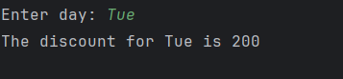

Question 3. Print first 10 odd and even numbers using iterators and compress. You can use duck typing.
Explanation:
odd_even_iterator Function:
This function takes a single parameter start, which represents the starting value of the sequence.
It generates a sequence of numbers from start to start + 19 (inclusive) using the range() function. This sequence will contain 20 numbers.
It then creates two selector lists:
odd_selector: This list alternates between True and False, repeating 10 times. This will be used to filter odd numbers.
even_selector: This list also alternates between False and True, repeating 10 times. This will be used to filter even numbers.
Finally, it filters odd and even numbers from the generated sequence using the compress() function from the itertools module.
compress() Function:
The compress() function takes two arguments: an iterable (in this case, the numbers sequence) and a selector list.
It returns an iterator that yields only those elements from the iterable for which the corresponding element in the selector list is True.
Returning Odd and Even Iterators:
The function returns two iterators: odd_numbers and even_numbers, obtained by filtering the numbers sequence using the odd_selector and even_selector lists, respectively.

Code:
from itertools import compress
def odd_even_iterator(start):
# Generate a finite sequence of numbers from start to start + 19
numbers = range(start, start + 20)
# Create a selector list for odd and even numbers
odd_selector = [True, False] * 10
even_selector = [False, True] * 10
# Filter odd and even numbers using compress
odd_numbers = compress(numbers, odd_selector)
even_numbers = compress(numbers, even_selector)
return odd_numbers, even_numbers
# Print first 10 odd and even numbers starting from 1
odd_iterator, even_iterator = odd_even_iterator(1)
print("First 10 odd numbers:")
for _ in range(10):
print(next(odd_iterator))
print("\nFirst 10 even numbers:")
for _ in range(10):
print(next(even_iterator))

Program Output:
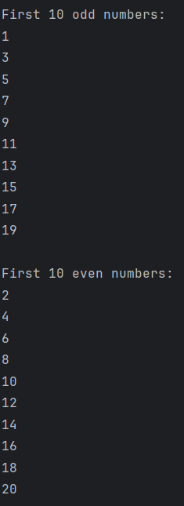

Question 4. Write a regular expression to validate a phone number.
Explanation:
Function Definition:
The function validate_phone_number takes one parameter phone_number, which is the string to be validated.
Regular Expression Pattern:
The pattern r'^\d{10}$' is defined using a raw string literal (r'...').
\d{10} matches exactly 10 digits (\d matches any digit, and {10} specifies that it should be repeated exactly 10 times).
^ asserts the start of the string, and $ asserts the end of the string. This ensures that the pattern matches the entire string, not just a part of it.
re.match() Function:
The re.match() function attempts to match the regular expression pattern (pattern) against the phone_number string.
If a match is found at the beginning of the string, re.match() returns a match object; otherwise, it returns None.
Return Value:
The function returns True if re.match(pattern, phone_number) is not None, indicating that the phone number matches the pattern and is valid.
Otherwise, it returns False, indicating that the phone number does not match the pattern and is invalid.

Code:
import re
def validate_phone_number(phone_number):
pattern = r'^\d{10}$'
return re.match(pattern, phone_number) is not None
phone_number=input("Enter a 10-digit phone number: ")
if validate_phone_number(phone_number):
print("Valid phone number")
else:
print("Invalid phone number")

Program Outcome:

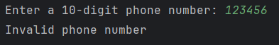

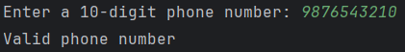

Question 5. Write first seven Fibinacci numbers using generator next function/ yield in python. Trace and memorize the function. Also check whether a user given number is Fibinacci or not.
Explanation:
fibonacci_generator Function:
This function is a generator that yields Fibonacci numbers indefinitely.
It initializes a and b to 0 and 1 respectively, representing the first two Fibonacci numbers.
It yields a (0) and b (1) initially.
Then, it enters an infinite loop where it updates a and b to the next Fibonacci numbers and yields b.
first_seven_fibonacci_numbers Function:
This function generates the first seven Fibonacci numbers using the fibonacci_generator function.
It initializes an empty list fibonacci_list.
It iterates seven times using a for loop and appends the next Fibonacci number obtained from the generator to the list.
Finally, it returns the list containing the first seven Fibonacci numbers.
is_fibonacci_number Function:
This function checks if a given number num is a Fibonacci number.
It initializes a generator object fibonacci_gen using fibonacci_generator.
It enters an infinite loop where it obtains the next Fibonacci number from the generator.
If the obtained Fibonacci number is equal to num, it returns True indicating that num is a Fibonacci number.
If the obtained Fibonacci number exceeds num, it returns False indicating that num is not a Fibonacci number.

Code:

def fibonacci_generator():
a, b = 0, 1
yield a
yield b
while True:
a, b = b, a + b
yield b
def first_seven_fibonacci_numbers():
fibonacci_gen = fibonacci_generator()
fibonacci_list = []
for _ in range(7):
fibonacci_list.append(next(fibonacci_gen))
return fibonacci_list
def is_fibonacci_number(num):
fibonacci_gen = fibonacci_generator()
while True:
fib_num = next(fibonacci_gen)
if fib_num == num:
return True
elif fib_num > num:
return False
first_seven = first_seven_fibonacci_numbers()
print("First seven Fibonacci numbers:", first_seven)
user_input = int(input("Enter a number to check if it's a Fibonacci number: "))
if is_fibonacci_number(user_input):
print(user_input, "is a Fibonacci number.")
else:
print(user_input, "is not a Fibonacci number.")

Program Output:

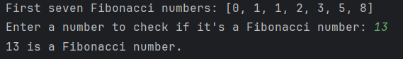
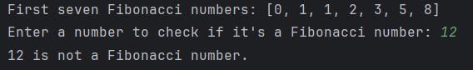

Question 6. Write a simple program which loops over a list of user data (tuples containing a username, email and age) and adds each user to a directory if the user is at least 16 years old. You do not need to store the age. Write a simple exception hierarchy which defines a different exception for each of these error conditions:
• the username is not unique
• the age is not a positive integer
• the user is under 16
• the email address is not valid (a simple check for a username, the @ symbol and a domain name is sufficient)
Raise these exceptions in your program where appropriate. Whenever an exception occurs, your program should move onto the next set of data in the list. Print a different error message for each different kind of exception.

Explanation:
UserDirectory Class: This class represents the user directory. It contains a dictionary (self.directory) to store user information.
add_user_menu Function: This function is responsible for adding a user to the directory. It prompts the user to input the username, email, and age. Then it calls the add_user() method of the UserDirectory class to add the user. If any exception occurs during the addition process, it catches the exception and prints the corresponding error message.
main_menu Function: This function displays the main menu options.
main Function: This is the main entry point of the program. It initializes the UserDirectory object and enters a loop to display the main menu continuously. Depending on the user's choice, it either calls the add_user_menu() function to add a user or exits the program.
Execution: The program continuously displays the main menu, prompting the user to choose an option. If the user chooses to add a user, it prompts for user data and attempts to add the user to the directory. If any errors occur during this process, appropriate error messages are displayed. If the user chooses to exit, the program terminates.
Code:
import re
class UsernameNotUniqueError(Exception):
pass

class AgeNotPositiveIntegerError(Exception):
pass

class UserUnder16Error(Exception):
pass

class EmailNotValidError(Exception):
pass

class UserDirectory:
def __init__(self):
self.directory = {}

def add_user(self, username, email, age):
if username in self.directory:
raise UsernameNotUniqueError(f"Username '{username}' is not unique.")
if not isinstance(age, int) or age <= 0:
raise AgeNotPositiveIntegerError(f"Age '{age}' is not a positive integer.")
if age < 16:
raise UserUnder16Error(f"User '{username}' is under 16 years old.")
if not re.match(r"[^@]+@[^@]+\.[^@]+", email):
raise EmailNotValidError(f"Email '{email}' is not valid.")

self.directory[username] = {'email': email}

def add_user_menu(directory):
username = input("Enter username: ")
email = input("Enter email: ")
age = int(input("Enter age: "))
try:
directory.add_user(username, email, age)
print(f"User '{username}' added to directory.")
except (UsernameNotUniqueError, AgeNotPositiveIntegerError, UserUnder16Error, EmailNotValidError) as e:
print(f"Error: {e}")

def main_menu():
print("\n1. Add User")
print("2. Exit")

def main():
directory = UserDirectory()

while True:
main_menu()
choice = input("Enter your choice: ")

if choice == '1':
add_user_menu(directory)
elif choice == '2':
print("Exiting program.")
break
else:
print("Invalid choice. Please try again.")

if __name__ == "__main__":
main()

Program Output:
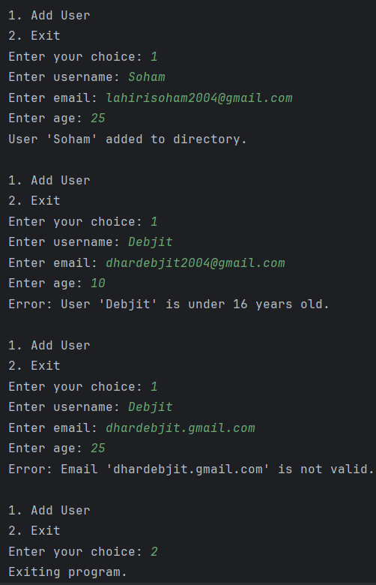

Question 7. Write a function findfiles that recursively descends the directory tree for the specified directory and generates paths of all the files in the tree.
Explanation:
Definition of find_files Function:
find_files function takes a single argument directory, which represents the directory to start the search from.
Inside the function, an empty list files_list is initialized to store the paths of all files found.
The os.walk() function is used to traverse the directory tree recursively. It yields a tuple (root, dirs, files) for each directory visited. root represents the current directory being traversed, dirs is a list of subdirectories in the current directory, and files is a list of files in the current directory.
Nested loops iterate over each file found in the current directory. For each file, the absolute file path is constructed using os.path.join(root, file) and appended to the files_list.
After traversing the entire directory tree, the function returns the list of file paths (files_list).

Code:
import os
def find_files(directory):
files_list = []
for root, dirs, files in os.walk(directory):
for file in files:
file_path = os.path.join(root, file)
files_list.append(file_path)
return files_list

directory_to_search = r'C:\Users\User\PycharmProjects\pythonProject1\Assignment 3'
files_found = find_files(directory_to_search)
for file_path in files_found:
print(file_path)

Program Outcome:
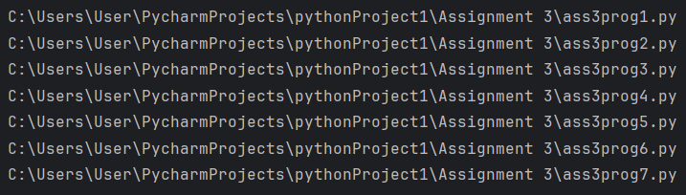

Question 8. Enumerate the sequence of all lowercase ASCII letters, starting from 1, using enumerate.
Explanation:
The dictionary comprehension {index: chr(97 + index - 1) for index in range(1, 27)} creates a dictionary where the keys are the indices starting from 1 (generated using range(1, 27)) and the values are the corresponding lowercase ASCII letters obtained by adding the index to the ASCII value of 'a' (chr(97)).
Each iteration of the comprehension generates a key-value pair where the key is the index and the value is the corresponding lowercase letter.
The resulting dictionary lowercase_ascii_dict contains all lowercase ASCII letters enumerated starting from 1.

Code:
lowercase_ascii_dict = {index: chr(97 + index - 1) for index in range(1, 27)}
print(lowercase_ascii_dict)
Program Output:

Question 9. Create a BankAccount class. Your class should support these methods: deposit, withdraw, get_balance, change_pin. Create one SavingsAccount class that behaves just like a BankAccount class, but also has an interest rate and a method that increases the balance by the appropriate amount of interest. Create another FeeSavingsAccount class that behaves just like a SavingsAccount, but also charges a fee every time you withdraw money. The fee should be set in the constructor and deducted before each withdrawal.
Explanation:
BankAccount Class:
It represents a basic bank account with attributes balance and pin.
Methods include deposit, withdraw, get_balance, and change_pin.
SavingsAccount Class (Inherits from BankAccount):
It adds an interest_rate attribute to the basic bank account.
Method calculate_interest calculates the interest earned based on the current balance and interest rate.
FeeSavingsAccount Class (Inherits from SavingsAccount):
It extends SavingsAccount by adding a fee attribute for each withdrawal.
Method withdraw deducts the withdrawal amount along with the fee from the balance.
Main Function (main()):
Initializes instances of SavingsAccount and FeeSavingsAccount.
Displays a menu of options for the user to choose from.
Options include deposit, withdraw, check balance, calculate interest (for Savings Account), change PIN, and exit
Depending on the user's choice, appropriate methods of the account objects are called.
The program continues running until the user chooses to exit.

Code:
class BankAccount:
def __init__(self, balance=0, pin=None):
self.balance = balance
self.pin = pin
def deposit(self, amount):
self.balance += amount
def withdraw(self, amount):
if amount <= self.balance:
self.balance -= amount
return amount
else:
return "Insufficient funds"
def get_balance(self):
return self.balance
def change_pin(self, new_pin):
self.pin = new_pin
class SavingsAccount(BankAccount):
def __init__(self, balance=0, pin=None, interest_rate=0):
super().__init__(balance, pin)
self.interest_rate = interest_rate
def calculate_interest(self):
interest = self.balance * self.interest_rate
self.balance += interest
return interest
class FeeSavingsAccount(SavingsAccount):
def __init__(self, balance=0, pin=None, interest_rate=0, fee=0):
super().__init__(balance, pin, interest_rate)
self.fee = fee
def withdraw(self, amount):
withdrawal_amount = super().withdraw(amount + self.fee)
if withdrawal_amount != "Insufficient funds":
return withdrawal_amount - self.fee
else:
return "Insufficient funds"
def main():
print("Welcome to the Bank!")
# Initialize accounts
savings_account = SavingsAccount(balance=1000, interest_rate=0.05)
fee_savings_account = FeeSavingsAccount(balance=2000, interest_rate=0.03, fee=10)
while True:
print("\nChoose an option:")
print("1. Deposit")
print("2. Withdraw")
print("3. Check Balance")
print("4. Calculate Interest (for Savings Account)")
print("5. Change PIN")
print("6. Exit")
choice = input("Enter your choice: ")
if choice == '1':
amount = float(input("Enter amount to deposit: "))
savings_account.deposit(amount)
print("Deposit successful. Updated balance:", savings_account.get_balance())
elif choice == '2':
amount = float(input("Enter amount to withdraw: "))
withdrawal_result = fee_savings_account.withdraw(amount)
if withdrawal_result != "Insufficient funds":
print("Withdrawal successful. Updated balance:", fee_savings_account.get_balance())
else:
print("Withdrawal failed. Insufficient funds.")
elif choice == '3':
print("Current balance:", fee_savings_account.get_balance())
elif choice == '4':
if isinstance(savings_account, SavingsAccount):
interest = savings_account.calculate_interest()
print("Interest earned:", interest)
print("Updated balance after interest calculation:", savings_account.get_balance())
else:
print("This option is only available for Savings Account.")
elif choice == '5':
new_pin = input("Enter new PIN: ")
fee_savings_account.change_pin(new_pin)
print("PIN changed successfully.")
elif choice == '6':
print("Thank you for banking with us. Goodbye!")
break
else:
print("Invalid choice. Please choose a number from 1 to 6.")
if __name__ == "__main__":
main()

Program Output:
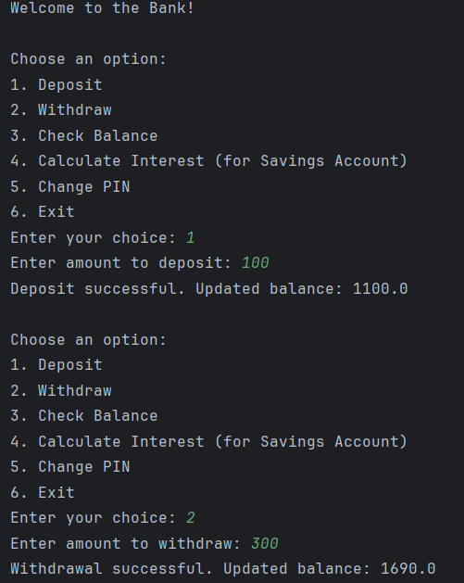
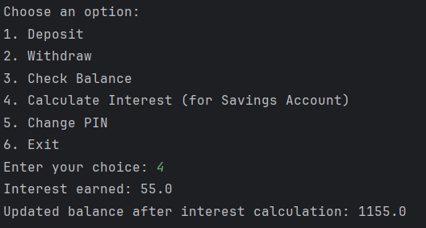

Question 10. Write a code which yields all terms of the geometric progression a, aq, aq2 , aq3 , ....
When the progression produces a term that is greater than 100,000, the generator stops (with a return statement). Compute total time and time within the loop.
Explanation:
We define a generator function called geometric_progression that takes two arguments: a (the first term of the geometric progression) and q (the common ratio).
Inside the function, we initialize two variables: start_time to record the starting time for measuring the total time taken, and loop_start_time to record the starting time for measuring the time spent within the loop.
We initialize the variable term with the value of the first term a.
We enter a while loop that continues as long as the current term (term) is less than or equal to 100,000. Within the loop:
We yield the current term, which means we output it as part of the generator sequence.
We multiply the current term (term) by the common ratio (q) to get the next term in the progression.
Once the loop terminates (because a term greater than 100,000 is reached), we calculate the total time taken by subtracting the start_time from the current time.
We also calculate the time spent within the loop by subtracting the loop_start_time from the current time.

Code:
import time
def geometric_progression(a, q):
start_time = time.time() # Start time for total time calculation
loop_start_time = time.time() # Start time for time within the loop
term = a
while term <= 100000:
yield term
term *= q
total_time = time.time() - start_time
loop_time = time.time() - loop_start_time
print(f"Total time taken: {total_time} seconds")
print(f"Time spent within the loop: {loop_time} seconds")
a = int(input("Enter first term: "))
q = int(input("Enter common ratio: "))
for term in geometric_progression(a, q):
print(term)
Program Output:
